**DAILY ONLINE ACTIVITIES SUMMARY**

|  |  |  |  |  |  |  |  |  |
| --- | --- | --- | --- | --- | --- | --- | --- | --- |
| **Date:** | **30/06/2020** | | | | | **Name:** | **Archana J C** | |
| **Sem & Sec** | **4th**  **‘A’** | | | | | **USN:** | **4AL18CS011** | |
| **Online Test Summary** | | | | | | | | |
| **Subject** | | **N/A** | | | | | | |
| **Max. Marks** | | **N/A** | | **Score** | | | **N/A** | |
| **Certification Course Summary** | | | | | | | | |
| **Course** | **Python and Django full stack web developer bootcamp** | | | | | | | |
| **Certificate Provider** | | | **Udemy** | | **Duration** | | | **2hours** |
| **Coding Challenges** | | | | | | | | |
| 1. **Write a C++ Program to Move all zeroes to end of array using Two-Pointers.** | | | | | | | | |
| **Status: Completed** | | | | | | | | |
| **Uploaded the report in Github** | | | | | **Yes** | | | |
| **If yes Repository name** | | | | | **https://github.com/alvas-education-foundation/archana_j_c** | | | |
| **Uploaded the report in slack** | | | | | **Yes** | | | |

Online Test Details: (Attach the snapshot and briefly write the report for the same)

N/A

Certification Course Details: (Attach the snapshot and briefly write the report for the same)

COURSE NAME : **Python and Django full stack web developer bootcamp**

CERTIFICATION PROVIDERS : Udemy

The course is all about the web development. I was learnt about html and css, and how to code using html and javascript.

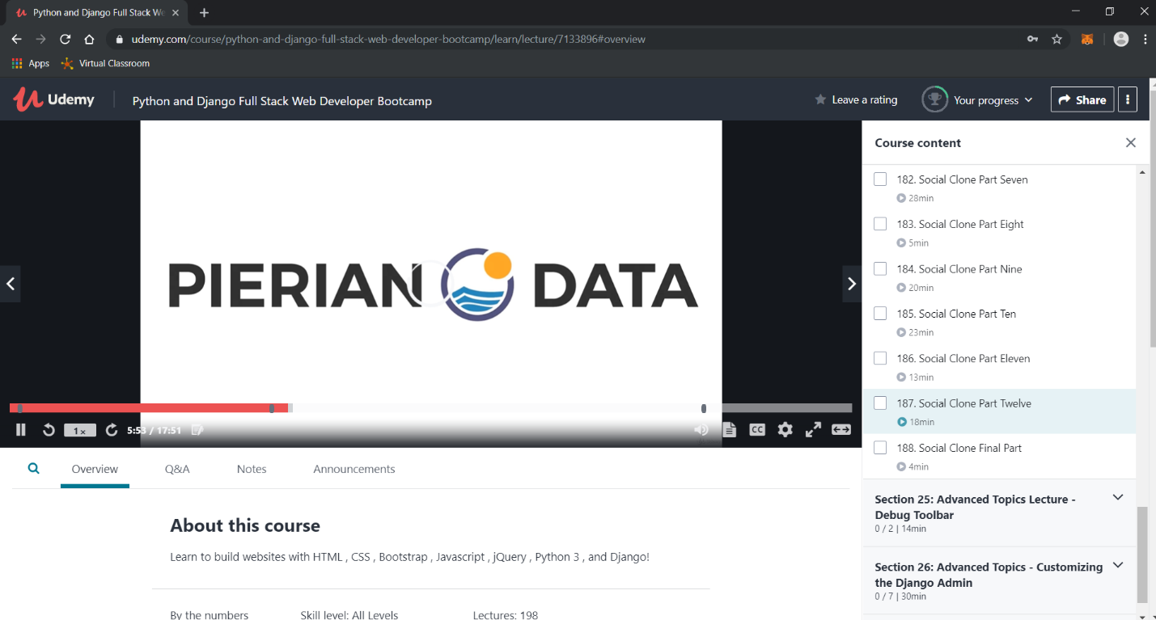

Coding Challenges Details: (Attach the snapshot and briefly write the report for the same)

Today I’m done with some c++ programs. The solution are already uploaded in github repository.

Program1 : Write a C++ Program to Move all zeroes to end of array using Two-Pointers.

